Title of the Satellite Meeting: Librarians and information professionals as (pro)motors of change: immersing, including and initiating digital transformation for smart societies
Date: Aug 20-21, 2019
Location: Zagreb, Croatia

Towards a new multichannel library customer experience and better staff’s digital competence within the regional development task in Finland

Jarkko Rikkilä
Regional development responsibility, Tampere City Library, Tampere, Finland.
Jarkko.rikkila@tampere.fi

Susanna Lampola-Autio
Tampere City Library, Tampere, Finland.
Susanna.lampola-autio@tampere.fi

Salla Hyökki
Regional development responsibility, Tampere City Library, Tampere, Finland.
Salla.hyokki@tampere.fi

Copyright © 2019 by Jarkko Rikkilä. This work is made available under the terms of the Creative Commons Attribution 4.0 International License: http://creativecommons.org/licenses/by/4.0

Abstract:

According to the new Finnish Library Act the public libraries in Finland are tasked with 1) providing access to materials, information and cultural contents; 2) maintaining versatile and up-to-date collections; 3) promoting reading and literature; 4) providing information services, guidance and support in the acquisition and use of information and in versatile literacy skills; 5) providing premises for learning, recreational activities, working, and civic activities; 6) promoting social and cultural dialogue.

Tampere City Library holds a regional development responsibility in the Pirkanmaa and Central Finland regions (abbr. PiKe). The purpose of this is to support the development of the public libraries and the professional competence of library staff as well as to promote mutual cooperation between the public libraries within the area of operation. Our main goal at the start was to improve ways of providing customer service in PiKe libraries.

Customer service is heavily connected to the job description of almost every library professional. Librarians serve customers in many different ways, both physically in libraries and virtually online. Our experience shows that customer contacts inspire professional development and motivate staff to learn new skills. The regular visitors of Finnish libraries give very high ratings for service on customer satisfaction surveys. However, our vision states that targeting especially new user groups challenge libraries to provide better user experience in digital channels.

We asked the staff how they meet users in different channels and what their level of digital competence in using different types of media was. The key findings include that for example 1) the use of mobile devices was surprisingly low. In addition, the 2) use of social media platforms was limited. The survey also highlighted development targets for 3) easier identification of the personnel and 4) more active engagement with the users in the library space.

We also conducted four in-depth customer insight workshops and a representative public survey with both library users and non-users (n = 730). The key findings indicate that the library staff could 1) offer their expertise more proactively and 2) take the needs of young customers better into account. We should be 3) more active towards customers in the library space. There’s a lot to improve 4) on the digital transformation, in exploiting the potential of multichannel customer service. The 5) use of workwear would help customers identify available staff.

Subsequently, a special training program for PiKe library service developers was launched. We built a plan for providing a unified customer experience across our libraries in the future. Emphasis was placed on dialogue, peer support and feedback. We learned ways to strengthen interaction and build a collaborative working culture. We considered tools to support an inclusive atmosphere and strengthen the confidence of librarians. We recognized the digital tools that support a better customer service and discussed the possibilities of digital transformation. Furthermore, all the work was packed in to a book which will be a field manual to the future work.

Keywords: multichannel customer service, customer experience, recommendation, social media, service design

Towards a new multichannel library customer experience and better staff’s digital competence within the regional development task in Finland

1. THE LAW OF THE LAND - THE NEW FINNISH LIBRARY ACT

Public libraries have a very solid grounded position in Finnish society. The Ministry of Education and Culture is responsible for the national library policy in Finland. However municipalities have the responsibility of arranging the public library services which are financed by the municipalities and the state together.

The basic tasks of public libraries have been defined in the Library Act. The first Library Act was introduced in 1928 and the latest in 2017. In particular, the new Act took into account a changing operational environment, digitalization, multicultural society, library´s role in promoting and confirming democracy in society and staff qualifications.

According to the new Finnish Library Act, public libraries in Finland are assigned with six tasks presented below. The first two are directly linked to library material, collections or content. The other four tasks represent a newer perspective to the traditional library paradigm and a lot needs to be done in libraries to really implement them in practice. The new tasks mentioned aptly cover pertinent changes in society and the changed operating environment of libraries.

1) Providing access to materials, information and cultural contents
2) Maintaining versatile and up-to-date collections
3) Promoting reading and literature
4) Providing information services, guidance and support in the acquisition and use of information and in versatile literacy skills
5) Providing premises for learning, recreational activities, working, and civic activities
6) Promoting social and cultural dialogue

2. THE REGIONAL DEVELOPMENT RESPONSIBILITY IN PIRKANMAA AND CENTRAL FINLAND REGIONS

After the 2017 Library Act was introduced, a new structure for developing Finnish public libraries was confirmed by the Ministry of Education and Culture. Instead of former 18 county libraries, the Ministry appointed nine large city libraries to be responsible for developing professional competence of library staff in each region. These nine developer libraries have started their duties in 2018. The state finances the new development tasks and extra staff has been recruited for it.

Tampere City Library holds a regional development responsibility in the Pirkanmaa and Central Finland regions (abbr. PiKe). Its purpose is to support the development of the public libraries and the professional competence of library staff as well as to promote mutual cooperation between the public libraries within the area of operation. Our main goal at the start was to improve ways of providing customer service in PiKe libraries. We believe this will be the emphasis far into the future as well.
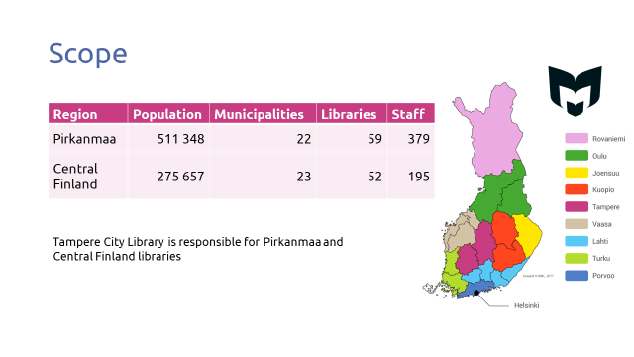
3. AIMING FOR A MULTICHANNEL LIBRARY EXPERIENCE

Customer service is heavily connected to the job description of almost every library professional. Librarians serve customers in many different ways, both physically in libraries and virtually online. The regular visitors of Finnish libraries give very high ratings for service on customer satisfaction surveys. However, our vision states that this is but one side of the truth. Targeting especially new user groups challenge libraries to provide better user experience in digital channels. What do we actually mean by service in today’s world?

The development of multichannel customer services is based on an understanding of changes in the environment and customer expectations. Customers' changing needs or perceptions of the service should be listened to with a keen ear. The multichannel customer experience refers to the fact that library services should be delivered through different channels. Channels are both physical and digital, in public space or virtual.

In the digital world the expectations of the user are defined across industry sectors. For example, the use of web based streaming services (Spotify, Netflix etc.) fosters expectations for similar functions in other services. To give a more precise example: personalized recommendation is a basic and fundamental function of many media apps and user interfaces. Therefore, similar requirements for better customer service are being targeted to libraries too.

In the end it is a matter of choice to decide what channels are used for different services. This question might be a crucial one for the future of libraries. When planning and designing services for the customer of future libraries, we should focus on the customer’s point of view. Customers should also have the opportunity to customize library services and facilities to suit their own interests.

4. FINDINGS FROM OUR STAFF INQUIRY

An internet survey was conducted among the library staff in the PiKe region (n = 245). The focus of the inquiry was to find out the current level of multichannel customer service, the tools used, strengths and opportunities for development, and the skills needed going forward.

We know from past experiences that it is the customer contacts that inspire professional development and motivate staff to learn new skills. We asked staff how they meet users in different channels and what their level of digital competence in using different types of media was. The key findings include that the use of mobile devices was surprisingly low, the use of social media platforms was limited, and there are development targets for easier identification of the personnel and more active engagement with the users in the library space.

#1 Limited use of mobile devices
According to the survey results, the most used tools in the library's customer service were the library system, computer and email. The use of tablets remained low even compared to the use of dictionaries and reference books. The use of smartphones was the fourth lowest among the tools included in the survey. The limited use of smart devices can be explained by the fact that the staff does not have the right tools for today's library work.

#2 Social media platforms should be part of customer service
Social media services were the second least used tools in the library customer service environment. This is somewhat surprising because social media channels such as Instagram, Facebook and YouTube should be seen as customer service channels like any other. Secondly, it is worth noticing that even in big organizations the responsibility to update social media can be assigned to a single employee.

#3 Easier staff identification
One of the key elements for more active service approach is the easy identification of staff. The survey gauged what kind of visual identification of staff could be useful in libraries. Respondents preferred small name tags and lanyards for identification. Reactions to casual workwear and accessories (vest, scarf, etc.) were fairly neutral, but more formal uniforms split opinions.

#4 A more active role towards customers
We have defined active library service as customer-friendly, positive, equal and consistent service. The components of active customer service are encountering different customers equally, follow through of customer service interaction and the approachability of the staff. Improvement should focus especially on frontline staff’s availability across library space and proactive recommendations. The service points should be made clearer.

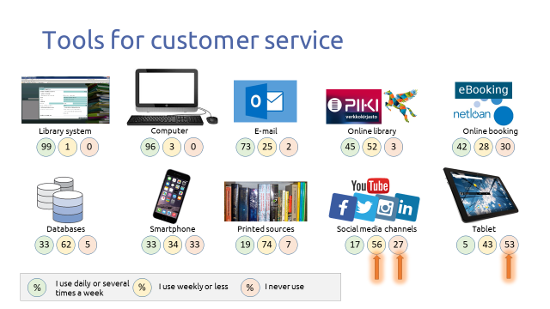

5. FINDINGS FROM THE CUSTOMER SURVEY AND CUSTOMER INSIGHT
WORKSHOPS

We conducted a representative public survey with library users and non-users (n = 730) to understand their perceptions and needs. The quantitative survey was complemented with a qualitative leg of the study: four in-depth customer insight workshops with regular library users, young customers and non-users in mixed groups. The key findings indicate that the library staff could offer their expertise more proactively and take the needs of young customers better into account.

In addition, we should be more active towards customers in the library space. There is also a lot to improve in tackling the challenge of digital transformation and exploiting the potential of multichannel customer services. Finally, the workwear could help customers identify available staff.

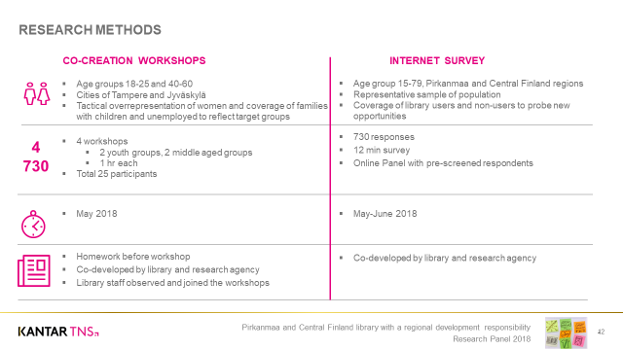
#5 Customers require more personal recommendations
We found out that 62 percent of respondents would welcome spontaneous recommendations of interesting books, music, movies and other material from library staff. In contrast, only 24 percent had actually received them. Personal recommendations seem to be more common in sparsely populated areas than in cities, maybe because the customers are familiar to the staff. However, customers find that the given recommendations do not match their interests particularly well, so there is a lot of room for improvement.
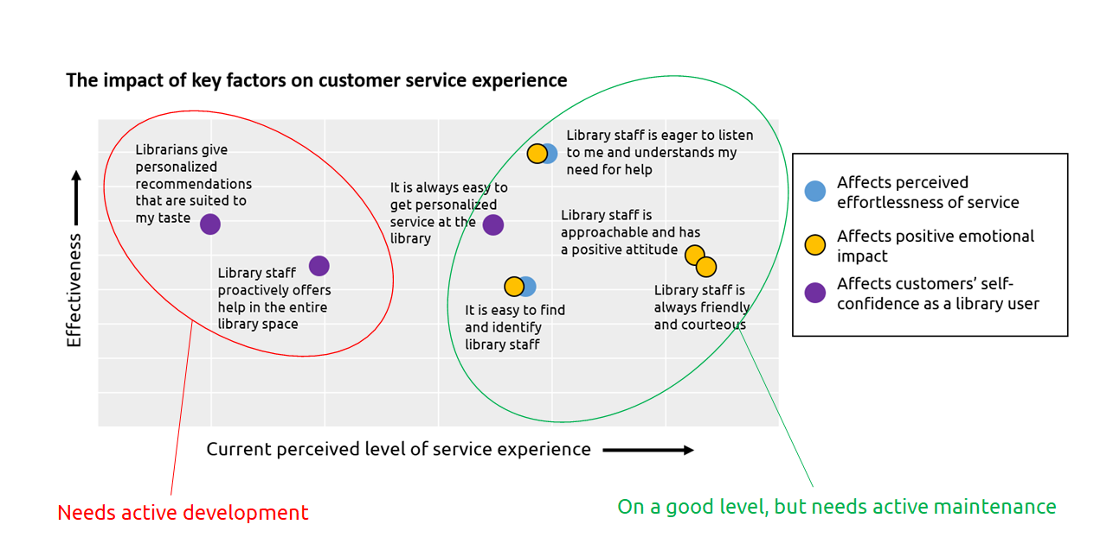
#6 Visual identification of staff should be improved
A clear result of our survey and workshops was that the identification of library staff is important for customers. Nonetheless, it is essential to notice that an identification is not a problem for regular library users. Mainly insecure customers, especially young people, would benefit from easier visual identification of staff.

#7 Stronger presence and library identity in social media
The importance of social media as a customer service channel is increasing, and it should be leveraged to target future library users. However, as many as 70 percent of respondents in our survey had not come across their local library in any social media. Many libraries have Facebook pages, but is that enough? Are our social media identities clear to customers?

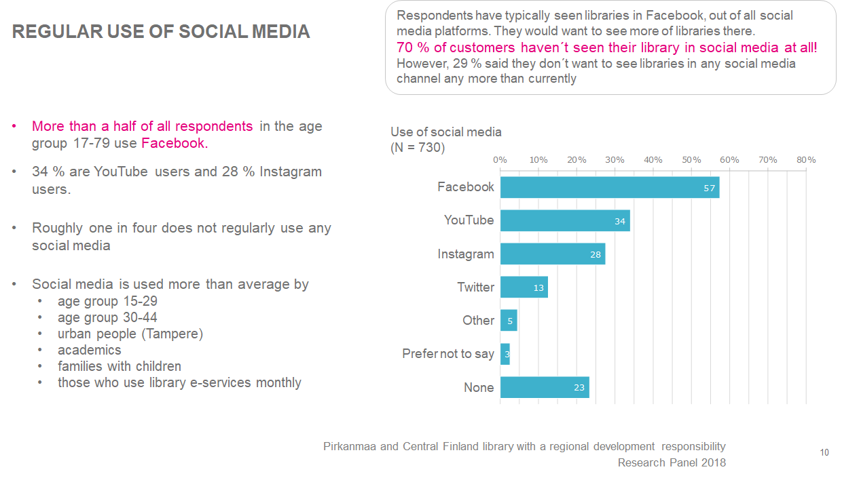

#8 We should focus especially on young customers’ needs
Young customers’ skills and self-confidence of using the library are weaker than that of regular customers. The lack of successful and pleasant staff contacts weakens their emotional experience. The staff should pay attention to young customers in the library space, and the library should be able to meet the needs of young people with increasing multichannel services.

6. BENCHMARKING FRESH IDEAS FOR STAFF TRAINING

In addition to the staff inquiry and customer survey we visited other companies used benchmarking to get fresh ideas to our development process.

Our visits focused on companies outside the library sector, for example Alko and Finnair. Alko is a national alcoholic beverage retailing company and Finnair is a globally recognized Finnish airline. Both companies have a proven track record of customer experiences. As we know, it is always beneficial to get perspectives from outside the library bubble.

At Alko, we clearly found out at the end that customer service is based on how you encounter your colleagues. One should focus on ways of greeting colleagues and creating a positive atmosphere. Alongside the development of digital service concepts and e-commerce, one will always return to this notion of positive human communication. A good spirit immediately causes better customer service results. Everything starts with people.

At Finnair, we talked about the meaning of values. Finnair's values are: I care, I simplify and I am brave. Values also guide the managerial training and shine through different levels of staff at Finnair. The supervisors can be good role models with their expertise and polite behavior. Focusing on employees’ enthusiasm and providing a platform for learning is a core function of the company.

7. THREE STEPS TOWARDS A BETTER LIBRARY CUSTOMER SERVICE

1 Build a customer-oriented working culture

Our common goal was defined collectively as: Pedagogically functioning and in-depth customer service that is present in all channels. In practice, this means we should develop professional skills that are linked to service encounters with customers - across channels. Importantly, organizing and facilitating cross-channel customer services is also a question of leadership.

Following the adage “People make the library”, we maintained that library workers need to be seamlessly involved in defining the future direction of the new better customer service in PiKe libraries. Together in the training sessions the future PiKe library service developers built a plan for providing a unified customer experience in all our libraries in the future. For some attendees, this kind of interactive co-creation was a novel experience.

Our key questions for building a new working culture were:
- What new skills are needed?
- What is the role of the library in the future?
- What services are we focusing on and what are we giving up?

2 Strengthen the communication

The development of the library's customer service starts with peer-to-peer encounters and appreciation of the work itself. Behind every successful customer contact, there is a lot of work that has been done behind the scene. So in this phase the emphasis was placed on how to improve dialogue, peer support and feedback. The PiKe developers learned ways to strengthen interaction, building cooperative working culture and inclusive atmosphere.

A checklist for better communication was created in the process:

1. Support the interaction
2. Be open and accepting
3. Show an example
4. Apply and modify
5. Brainstorm
6. Do more together
7. Share your knowledge and skills
8. Discuss by asking questions
9. Use the available tools
10. Stop to think at times
11. Learn constantly from feedback

3 Bring new digital tools to customer contacts

The staff inquiry revealed that librarians need help in using digital solutions and new tools in their daily work. Customer survey findings also emphasized the idea that customer service can be improved in various digital channels. The development of these items was the focus of the third step.

New technologies can be used to rethink work tasks or as everyday helpers. For example, the new Central Library Oodi in Helsinki is using robotics for certain basic tasks such as transporting book boxes between the floors of the building. However, the starting point is always that people use technology. Technology alone is inadequate in itself - however autonomous it may be - but its use is channeled through the reform of goal-oriented work.

We discussed the following questions: Could robots be used to streamline routine tasks and provide everyday help? Could audio interfaces improve the service experience of some customer groups? How are virtual reality solutions used in library services? What kinds of models could interior positioning tools offer in the library to guide customers? How do we enable touch screens in the promotion of our services?

8. DIGITAL COMPETENCE OF THE FUTURE LIBRARIAN

The training program cited above was focused on creating a network of PiKe library service developers as champions and ambassadors of customer service development. Nevertheless, this alone is not sufficient. The training continues throughout 2019, still drawing on the key findings of the inquiry and survey. The future implementation has two aspects. Firstly, in autumn 2019 we are training the heads of services, and secondly, we are improving library workers’ digital skills with a tailored program.

For improving digital skills and know-how in our region’s libraries we created a Digital Driving License for librarians. This is a set of motivational study modules designed to support digital skills of PiKe personnel, providing basic skills in giving digital instruction to library customers. The Driving License consists of one obligatory module and four optional modules.

After completing the Digital Driving License training program the library worker can:
- Use e-materials and e-services needed in work
- Use a range of digital devices and give digital instruction to customers
- Design and produce a variety of multimedia content

9. CONCLUSION

A motivated employee creates a distinctive, memorable and pleasant customer experience in the library. One of the fundamentals is that a good customer experience and employee experience are two sides of the same coin. Therefore, if we want to improve the customer experience we need to invest in the personnel. The method of service design is based on seeing the library from the customer’s perspective.

We felt it crucial to document the work on customer service development in a tangible form. The outcome of our process was published as a workbook for the future. The book is called Customer service in PiKe libraries - with new steps ahead to encounters. It is available as an e-book in Finnish.

A six step toolkit for a better customer service outlined in the book is summarized below. The most important thing for us would be to recognize the behaviors, needs and expectations of customers and more closely focus on the future customers and non-users of library services. It is every librarian’s responsibility to obtain or refresh the skills needed for this, and the libraries should build platforms for this.

1. THINK LIKE A DESIGNER. Take a walking tour in your own library and look at the space through the eyes of a customer. Do we have enough space for customers to work? Is there space for customer’s own activities and leisure interests?

2. UPDATE YOUR EXPERTISE. High quality customer service is the driver for customer satisfaction and equally important for frontline staff as a powerful catalyst of motivation. Can we really understand this? Do we update our expertise to be able to meet new customers’ needs?

3. BE A LIBRARY AMBASSADOR. Is it clear how everyone can work as an ambassador of the library? Start a conversation about roles and practices in the customer service teams. Identify opportunities for improved customer service interactions. Work out the best practices together as a team.

4. LEARN TO USE DIGITAL SERVICES. Learn how to use the most common mobile devices and your library’s own e-services. Learn how to recommend digital library services and content to customers. Make sure your library has up-to-date equipment to do this.

5. RECOMMEND AND PROMOTE. How are the multiple channels of library services (online catalogue, chat, social media, library apps etc.) promoted to customers? Learn to master the digital channels and advocate for the whole range of library services there.

6. CO-CREATE WITH CUSTOMERS. Listen to your customers and give them opportunities to develop services together with you. Staff participation and internal strategic design work is equally important.
Acknowledgments

Big thanks to the Ministry of Education and Culture, to all the PiKe developers and personnel that participated in our training sessions and to our fantastic PiKe-team: Pirkko Lindberg (Tampere City Library), Seija Laitinen-Kuisma (Jyväskylä City Library), Susanna Lampola-Autio (Tampere City Library), Hanna Martikainen (Jyväskylä City Library) and Mika Mustikkamäki (Regional State Administrative Agency - Western and Inland Finland).
References
The Finnish Library Act 2016. https://www.finlex.fi/en/laki/kaannokset/2016/en20161492.pdf
Customer service in PiKe libraries - with new steps ahead to encounters. Available in Finnish: Asiakaspalvelu PiKe-kirjastoissa - Uusin askelin kohtaamisiin. https://www.tampere.fi/kirjasto/pike/pike-kirja/

